2022 Leadership Roundtables
Registration Form
Special Roundtable Price Today Only ----$70.00 (non-refundable)
Roundtables with: Gerald Brooks & Tony Cooke
______St. Louis, MO – March 15, 2022 ______Rancho Cucamonga, CA – April 7, 2022
______Atlanta, GA – May 10, 2022 ______Canton, OH – Oct. 4, 2022
______Plano, TX – January, 2023 ______Puyallup, WA – February, 2023
______Oviedo, FL – 2023 ______Albuquerque, NM – March, 2023
Roundtables with: Gerald Brooks
______Nashville, TN – Mar. 24, 2022
Church Strategic Conference
______Miami, FL – Aug. 8, 2022 _______New Braunfels, TX – 2022
Breaking the 500 Barrier
______Pittsburgh, PA – Aug. 22, 2022
Register and pay at the Roundtables Registration Table under the tent outside to secure your spot.
Name ___________________________________________
Church Name _____________________________________
Senior Pastor ______________________________________
City_________________________________ State________
Phone (______) _______ - ____________
E-Mail___________________________________________
Number of people registering _________________________

Gerald Brooks

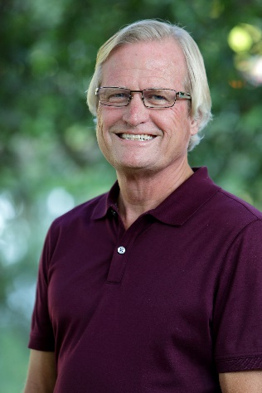

Gerald Brooks, the founding pastor of Grace Church in Plano, Texas, is well known internationally for his passionate heart to mentor other pastors. Pastor Brooks hosts the annual North Texas Leadership Conference in Plano, drawing ministers from all over the nation. He teaches leadership across the country through church growth seminars and regional roundtables. His monthly podcasts provide ministers and business leaders with innovative tools and practical wisdom.
Pastor Brooks, along with his wife, Geni, founded Grace Church in 1982. Grace is a multi-cultural, multigenerational, interdenominational church targeting youth and children. The church creates an environment where the lost can be saved and the saved can serve.
Recognized for his distinguished service to the body of Christ, Pastor Brooks has received the Doctor of Divinity from Beulah Heights University and the Doctorate of Christian Leadership at Ohio Christian University. He was inducted into the Martin Luther King, Jr. Board of Preachers at Morehouse College. He was named to the John Maxwell Equip Hall of Fame Inaugural Class. As a member of the Equip Board of Directors, Pastor Brooks partners with John Maxwell to help raise up international Christian leaders to fulfill the Great Commission in every nation.
He is a contributor to the New Spirit Filled Life Bible and the author of fourteen books, including Leadership According to 1 Corinthians 13, Understanding Your Pain Threshold, and Survival Skills.
Pastor Brooks and Geni have been married 44 years and have three children, Wendi, Kayci, and Cody, and six grandchildren.

Practicalities for Pastors: Ways to Manage Your Gift
Roundtable 2022 Pastor Gerald Brooks
- Never put your _______________________ health in the hands of someone else.
- Ministry creates emotional demands. COVID has escalated them.
- Individuals do not resolve your emotional needs; they ________________ them.
Acts 26:17 (KJV) Delivering thee from the people… unto whom now I send thee.
- Emotional/mental health has to become a priority.
- Getting us _______________ is the key to getting ministry right.
- Grow to your _______________, not just to your circumstances.
2 Corinthians 3:18 (MSG) And so we are transfigured much like the Messiah, our lives gradually becoming brighter and more beautiful as God enters our lives and we become like him.
- Too often leadership is about ______________________. But to be sustainable, it must be bigger than this.
- Problematic leadership is the _____________________ level of leadership.
- Your _____________ becomes your strength.
- No one expects you to do everything, but everyone wants you to do __________________ thing.
- Do not hire someone you will always need to be ministering to.
- The larger the platform the greater the _____________________.
- The devil will give you _____________________ to stop your ministry.
- Success can create false positive.
  - Opportunities to ___________________ you.
  - Stage to addict you.
  - People to ____________ you.
- The test of success: can you ___________ it away.
- Never handle an issue from the pulpit that you can handle in ___________________.
- Understanding boards and ___________ and what.
- You can’t change a heart without giving your _____________________.
- Leadership lessons do not replace a leadership ____________________.

  - If you are not teaching leadership, you do not get leaders.
  - If you do not look for leaders, you will not find ___________________.
  - Leadership is a team issue, not just a pastor issue.
  - If you do not require others to look for leaders, they are the _________________________.

What Happens When Ministry Hits Critical Mass
Roundtable 2022 Pastor Gerald Brooks
Intro
- Critical mass is a physics term which describes a process of events that lead to a chain reaction of fissionable materials, resulting in a meltdown or explosion.
- In modern history, it’s Chernobyl.
- A meltdown which resulted in a series of _____________________.
- Without getting bogged down in physics, there are clear observations. Nuclear power plants must:
- Be taken _________________________
- Never cut corners
- Never play _____________________.
- These ideas are applicable to ________________________.
- The current ministry landscape is seeing frequent meltdowns and explosions, which appear to be increasing.
- ________________________ have to be put into place.
- We must examine others who have gone through critical moments to _______________________ them in our lives.
- Eventually, if you serve long enough, you will face _______________________ moments.
- Let’s get personal.
- Critical mass always involves a ________________ of events gone _________________.
- 2004 – nearing 27 years of ministry, the grind and hits taken toll – can’t happen young – bad habits can.
- There were ministry models I had lived by which in hindsight were ______________.
- Added was an ongoing crisis moment which required sustained ______________________.
- Then my sister had terminal cancer and my parents divorced after 49 years
- 2008 economic crash

- The sequence of events created __________________________ moments.
- My mind will reach a breaking point.
- Other than the __________________, I could no longer function.
- Lessons learned
- Critical mass moments you seldom see ____________________.
- ________________ is the first response.
- It took time to get here, and it will take _______________ to get out.
- _________________________ must be acknowledged.
- Health has to be pursued.
- ___________________________ must be made.
- Streamline your prayers.
- Downsize your __________________________.
- __________________________ better does not mean you are better
- Once you go there, you must make sure you don’t return there.
- __________________________is a must.
- Choose your team wisely.
- Share your story __________________________.

The Reoccurring Question: How Do I Make My Team Better?

Roundtable 2022 Pastor Gerald Brooks
- The question: how do I get my team better?
- Do ______________ best better
- The challenge is people are raised hearing, “Just do your best.” This phrase becomes the ____________________.
- Never let your best be an ________________ for not getting better.
- Don’t let your best become your ____________.
- How to do your best better
- To do your best better, you have to ___________ better.
- Can you recognize there are people better than you?
- Can you _______________ from those better than you?
- Can you learn from those who may not be better than you?
- The tendency towards better
- Better: ____________________________
- Doing better: minimize
- Something better: ________________________
- The Truth
- If you don’t __________________ for better, you don’t get better.
- If you don’t _________________ better, you don’t get better.
- The Goal
- The question: Who are you ______________________ from that’s better than you?
- If you don’t have a plan to be better, you don’t get better.
- Doing your best better isn’t a _________________ question, but a growth question.
- What is your plan?
- _________________ is your plan?

- No goals, no growth.
- Whatever God has given me, I have do it better.
- Being better at _______
- Being better at God
- Being better at ___________________
- Being better at my best
- Better doesn’t happen by _________________________.
- Practice for better
- To do your best better, you have make _____________________ better.
- To do your best better, you have to ____________________ better.
- To do your best better, you have to be ________________ better.
- To do your best better, you have to do __________________ better.
- Better is not about tomorrow. Better starts today.
- Today is a decision; it’s not an ________________________.
- Today is discipline; it’s not a feeling.
- Find a _______________________ to be better.
- Find a way to be better.
- Find _______________________ to be better.
- Find people who make you better.
- Find _______________________ to get better.
- To do your best better, say _______ to excuses that don’t make you better.
- The _______________________ won’t let me. (Organization answer)
- People around me aren’t growing. (Relationship answer)
- I am better than _______________________. (Comparison answer)
- But people like me. (7th grade answer)
- I have so much to ______. (Time answer)

Tony Cooke
www.tonycooke.org
office@tonycooke.org
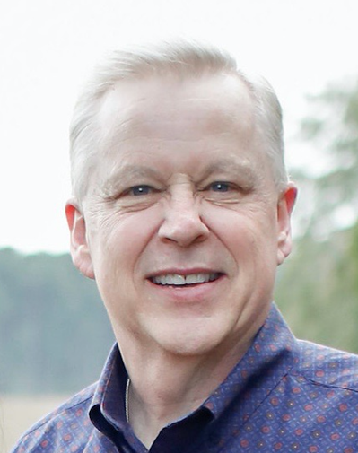
918-645-9120

Bible teacher and author Tony Cooke graduated from RHEMA Bible Training Center in 1980 and received degrees from North Central University (Bachelor’s in Church Ministries) and Liberty University (Master’s in Theological Studies/Church History). His ministerial background includes pastoral ministry, teaching in Bible schools, and directing a ministerial association. Tony’s passion for teaching the Bible has taken him to more than thirty nations and nearly all fifty states. He is the author of a dozen books, of which, various titles have been translated and published in eight other languages. Tony and his wife, Lisa, reside in Broken Arrow, Oklahoma, and are the parents of two adult children.

Tony has authored the following books:
- Life After Death
- In Search of Timothy
- Grace: the DNA of God
- Qualified, Through the Storms
- Your Place on God’s Dream Team
- The Work Book: What We Do Matters to God
- Lift: Experiencing the Elevated Life
- Miracles and the Supernatural Throughout Church History (Release: Summer 2020)

Tony has also produced video curriculum for churches that accompany six of these books.
Prior to traveling, Tony was involved in pastoral ministry for more than twenty years, and served as an Instructor and as Dean of Rhema Bible Training Center. He also served as the Director of an International Ministerial Association for thirteen years.
Glimpses into Teamwork: They Did it Together
Tony Cooke
www.tonycooke.org

When God wants to do something in the earth, he starts with a leader, but he finishes with a _______________________.

In Scripture:
- Moses and Joshua
“Moses arose with his assistant Joshua, and Moses went up to the mountain of God” (Exodus 24:13).

- David and Jonathan
“…the soul of Jonathan was knit to the soul of David, and Jonathan loved him as his own soul… Then Jonathan and David made a ________________________, because he loved him as his own soul” (1 Samuel 18:1, 3).

- Elijah and Elisha
“Elisha… who poured water on the hands of Elijah” (2 Kings 3:11).

1. Serve the ______________ of God.
2. Respect the office.
3. Learn to work with the _____________________ of others.

- Paul and Timothy

“For I have no one like-minded, who will sincerely care for your state. For all seek their _______________, not the things which are of Christ Jesus” (Philippians 2:20-21).

Like-minded, from the Greek: Equal Soul.

- Peter and Mark

“…Mark, my son” (1 Peter 5:13).

All God-ordained _______________________________ Should be Win-Win Relationships.

Symbiotic Relationships: A mutualistic, long-term relationship between different species wherein both organisms benefit from the interaction.

Syn – Together
Bios – Life

Symbiotic = ________________ Life
"There is no more noble occupation in the world than to assist another human being—to help someone succeed."
- Alan Lay McGinnis

"Few people are successful unless a ____________ of other people want them to be."
- Charles Brower

How Have Symbiotic Relationships Worked Throughout Church History?

The Three Cappadocian Brothers
- Basil of Caesarea (AD 330-379)
- Gregory of Nyssa (AD 332-395)
- Gregory of Nazianzus (329-390)

Gregory said of Basil, “His words were like thunder because his life was like lightning.”

Martin Luther — Philip Melanchthon

Charles Finney – Clary & Nash

D. L. Moody – Ira Sankey

“Mr. Moody preaches the Gospel and Mr. Sankey _____________ it.”

Oswald and Biddy Chambers

Billy Graham – His Associates

“I learned from Graham to build your ministry on a team. He knew this, and he built a core team that was with him fifty years. Everybody on the team brought strengths to the table. When you build an effective team, you hire people who compensate for your weaknesses and who mobilize or reinforce your strengths, because nobody can be good at everything.”
- Rick Warren

“In order to do whatever needed to be done, they have subordinated their personal privileges, reordered their priorities, accepted disappointments and endless changes in schedule, stretched their patience, absorbed criticism, and exhausted their energy. They were the Heaven-sent ones who propped me up when I was sagging and often protected me from buffetings that would have scared me or scarred me otherwise. They did not back away from correcting me when I needed it or counseling me with their wisdom when I faced decisions. I’m convinced that without them, burnout would have left me nothing but a charred cinder within five years of the 1949 Los Angeles Crusade.”
- Billy Graham

Norm Dubois

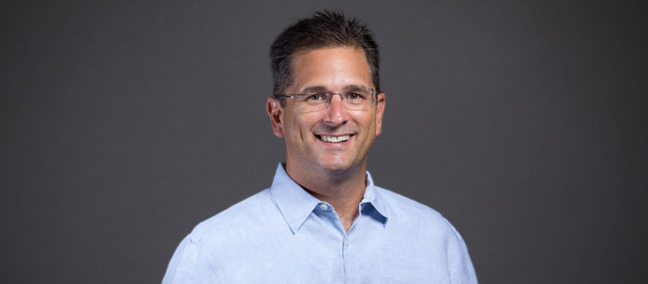

Norm Dubois is the founding and lead pastor of East Coast Believers Church. A native Floridian, he earned a finance degree from The University of Central Florida. The Dubois' spent 11 years in full-time ministry in the U.S. and abroad before starting East Coast Believers Church in 2003.
Norm serves with a true pastor’s heart and preaches the Bible with boldness and simplicity. He believes in the mission of the local church and that the power of God's Word can change lives. His heart is to see the people of ECBC live out their God-given dreams and make a positive impact in the Orlando area and beyond with the Good News of Jesus.
Norm and Dina reside in Oviedo, Florida along with their five children and consider it an honor that God has given them the privilege to serve as the pastors of East Coast Believers Church.

Leadership Crisis
Leadership Roundtable – Orlando, FL Pastor Norm Dubois
#1 Too many are _________ or leaving ministry today.
- More churches _______ in the U.S. than _______ in 2019. -Christianity Today
- ________ churches have shut down from March 2020 – Dec. 31, 2021 in the United States. -Kinniman, Baptist Courier
- __ out of ___ who start in ministry today will finish. -Steve Farrar
- Your ______________ really matters and has nothing to do with the size of it.
- ______ is counting on you to finish.
- _________ are counting on you to finish.
#2 The choice is:
- ______ your life - Temporary
- ______ your life - Regret
- ______ your life - Eternity

#3 _________ your heart.
Proverbs 4:23 (NLT) Guard your heart _____________, for it determines the course of your life.

- ___________- Have to get used to it as a leader.
Prov 18:19 A brother wronged is more unyielding than a fortified city.

- Discouragement/___________
PS 13:2 How long must I wrestle with my thoughts and day after day __________ in my heart?

- ______________
Romans 8:5 Those who are dominated by the sinful nature think about sinful things, but those who are controlled by the Holy Spirit think about things that please the Spirit.

- Guardrails:
  - __________- To feel
  - __________- To have
  - __________- To be

1 John 2:15- 16 Do not love the world or anything in the world. If anyone loves the world, the love of the Father is not in him. For everything in the world — ____________, the ____________ and the _______________________ — comes not from the Father but from the world.

- _______ in your lane.
- “Faith is when we trust God. _____________ is when God can trust us.”-Gerald Brooks
- ___________ to the Holy Spirit.
- Pray or die.
- _____________ not ministry.
#4 To finish we have to get back to the _________.
- I __________ to, I _____ to.
- The local church ________ the hope of the world.
- One day we want to hear Jesus say, _____________.
Rev 22:12 “Behold, I am coming soon! My reward is with me, and I will give to everyone according to what he has done.”
- There are days _______________ if I don’t remember why.
- If you are discouraged or distracted... there is more, _____________.

